synopsis on
AnyPoint: EFFICIENT Ubiquitous Location Identification and information Desimination


M S RAMAIAH INSTITUTE OF TECHNOLOGY
DEPARTMENT OF COMPUTER SCIENCE ENGINEERING

PROJECT GUIDE: Dr. VIJAYA KUMAR B P

SUBMITTED BY:
ASHWIN NAIK 1MS08CS059
PRASHANTH M MULGE 1MS08CS076
SARVESH GADEKAR 1MS09CS412
SIDDHAVEERAIAH T M 1MS08CS114
PROJECT TITLE:
AnyPoint: EFFICIENT Ubiquitous Location Identification and information Desimination
PROBLEM DEFINITION:
With the increase in mobile computing devices and wireless LANs, it has become important to determine the location of a device at any point in time. Several applications can be conceived of that can use this information. Detecting the location is one of the first steps towards building context sensitive smart devices. For example, colleges can use such a technology to build location aware hand-held devices. As a visitor/student walks into a campus, holding such a device, information about the campus such as lecture halls, staff rooms flashes on the screen.
Global positioning systems or positioning provided by mobile telephony operators are suitable for outside environments where clear line-of-sight respect to the satellites or base stations is available. However, they suffer from multi-path effects within buildings, and therefore, in indoor they show poor performances. The use of Wi-Fi signals as a potential positioning system within buildings has opened doors for many applications is because of the ubiquitous availability of Wi-Fi signals in almost all the buildings. So no additional hardware is required to install a positioning system in the buildings.
The application makes use of algorithms to locate the position of the user using Wi-Fi, Gps or any available networks in an efficient manner and provide services based on the position of the user.
FUNCTIONAL REQUIREMENTS:
USER REQUIREMENTS:
User require a location-based service (LBS) which is an information or entertainment service, which is accessible with mobile devices through the mobile network and which uses information on the geographical position of the mobile device.

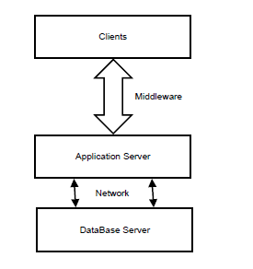
DATA FLOW DIAGRAMS:

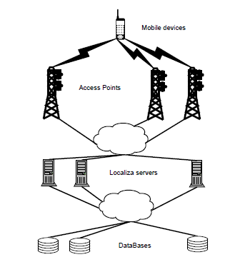
FIG1: LOGICAL ARCHITECTURE

FIG2: PHYSICAL ARCHITECTURE

INPUTS AND OUTPUTS:
Input: automated position of the user with respect to the access point.
Output: services based on the location of the user with respect to the access point.

HARDWARE/SOFTWARE REQUIREMENTS
- Wi-Fi and GPS enabled mobile device
- Wi-Fi Access points
- JAVA/J2ME platform

APPLICATIONS:
- It can be very useful for contextual information systems. When a user demand an information from its mobile device, the response will be configured depending on the origin of this request.

- Another application would be a system that locates a device in a transparent way. That is, a mobile device will be located without user request. Suppose the case of a fair, in which each visitor receives a terminal susceptible to be located; in this way the organization could take a control of the visits ’stands’, adapt the quality of the contents for future editions.

- Preventing unauthorized access in high end security systems.

